**BME 7310 Computational Laboratory #2**

Due: 9/14/2023

**Problem 1: Concepts in Divergence.**

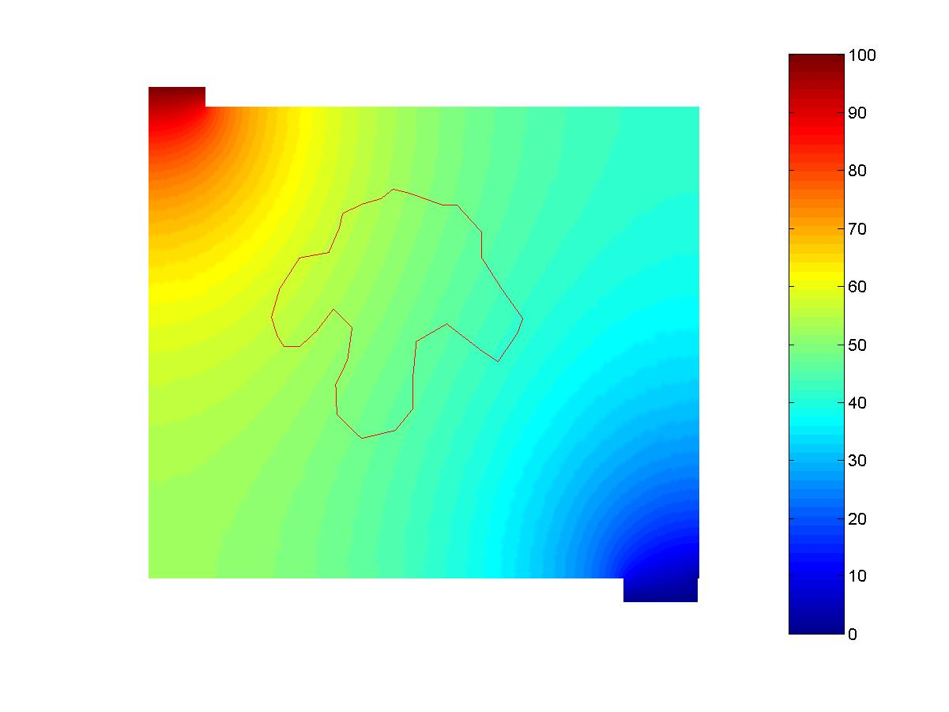a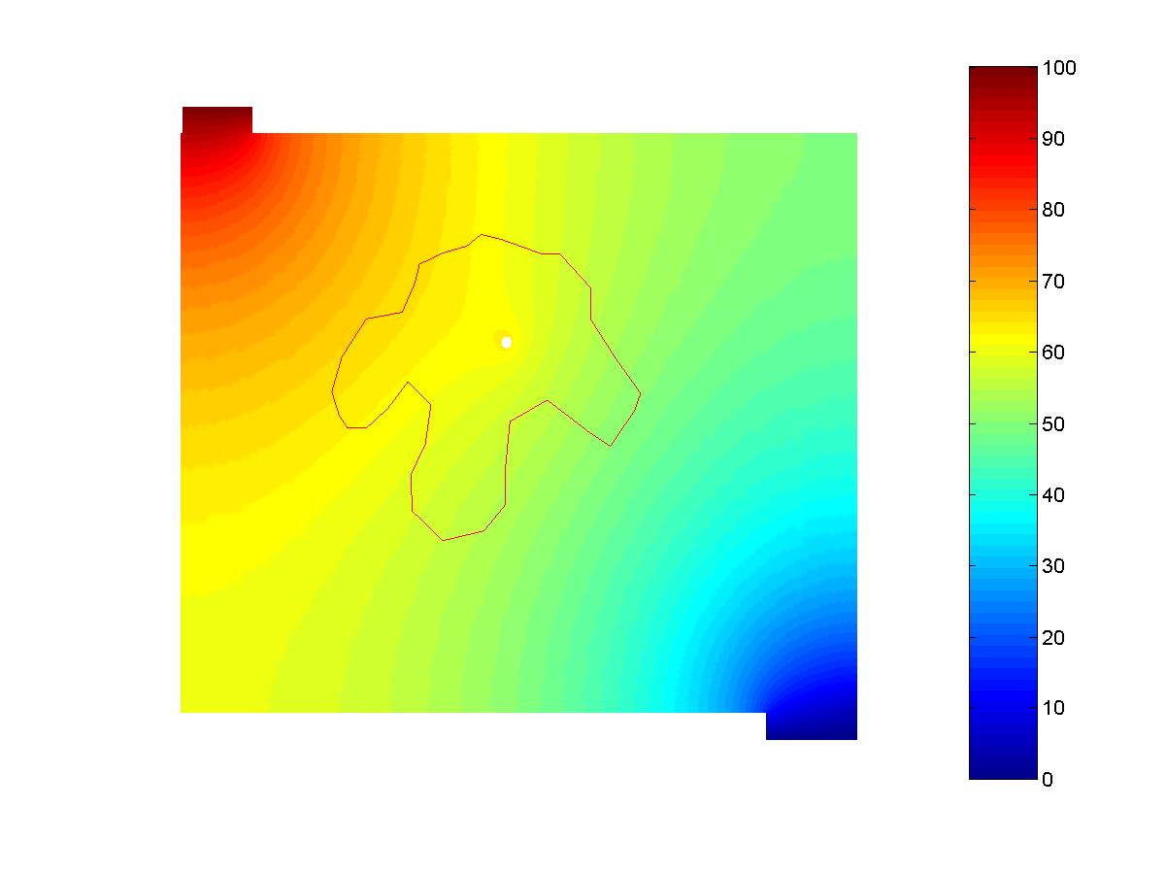b

**Electro-potential distributions (a) Scenario #1, (b) Scenario #2.**

Often electrostatic potential theory is used to represent the distribution **of current within the brain**. In the two scenarios above, a very basic distribution of potential (i.e. voltage) is illustrated. Laplace’s equation was used for each problem. It highlights the flow of current from the top left to the bottom right of the images. Within the domain, an arbitrary contour is shown. The image to the right shows an additional structure which influences the domain.

You have been provided 2 files for each scenario above. The two files for each scenario are: POINT_LIST_#.DAT, and LINE_LIST_#.DAT .... where the # is associated with each scenario.

POINT_LIST_#.DAT has the format: [point index] [x position] [y position] [**Jx**] [**Jy**]

LINE_LIST_#.DAT has the format: [**contr. line index**] [**contr. node 1**] [**contr. node 2**]

For reference, the contour nodes are arranged such that for each contour line segment, it is arranged as traversing the boundary in a counter clockwise manner.

a. Your task is to **calculate the following line integral: curl integrate along curve? This interate normal to curve.. 2D to 1D rep?**



and **report the values for each of the scenarios above**. Be sure to submit any MATLAB code used to achieve your results.

-- expand ti a series a function

Jn = sum(c_j * phi(s)_j) = sum(Jn_j * phi(s)_j) 🡪 if chose Lagrander polynomial

Dot(J*n) = Jn --🡪 sum all Jn1 * L/2 + Jn2 * L/2

For each segment:

Compute Jn_i part of Lagrange = Jn_i * n_i 2 points / 3 points every iteration?

Then sum

­­­­

b. After getting your results, what can you say about your solution with respect to your understanding of the **divergence operator**? Also, if the results were not exactly what you expected, can you suggest a reason why? What is the influence of the **additional structure in the additional domain**?

Here we have Jn as a vector field. Divergence represents the **outward flux of a vector field** across the curve. Div(Jn)

**EFFECTS OF HAVING PHI1 and PHI2? What is Jn1 & Jn2 🡪 looks like one term disapear**

c. In class, we performed an integration **over a singl­­­e contour line** and produced the following:



If I were to change the integral to , what would the result be **for all points**. If I were to change the integral to  **for all points**, what would the result be? For this problem assume the same **2-node domain that was in the lecture with the “rooftop” function**.

**Problem #2.** **Understanding Current:** **Conservation of cortical current** is governed by the PDE

(1)

where  is the **electrical current density**. Often  is expressed with respect to **tissue potential changes**, this can be expressed as the **gradient** of **a scalar potential Φ**, and electrical conductivity *s.*

(2)

Hence equation (1) can be recast in terms of Φ as,

(3)

under **homogeneous electrical conductivity**, it can be written as (Laplace equation):

(4)

Your job is to compute *point iterative solutions­* of (4) when discretized by **center finite differences** under the following scenarios:

**(a)** Even though you will be solving equation (4) below with respect to the computational model, in this part write out the **full FD description approach for equation (3)**. Be sure to address the material property.

**(b)** Given the problem **domain** and **boundary conditions** below, **compute the solution of Φ** using ***Jacobi* iteration** with an initial solution vector **of Φ=0 everywhere**.

* Iterate until reaching an ***absolute L∞ norm-based error*** of successive iterates of **less than 1x10-5** and report the number of iterations needed to reach this convergence criterion.
* Estimate the spectral radius (largest eigen value – diagonal dominance equation) of the Jacobi iteration matrix during the course of the iterations and compare with the theoretically expected value.
* Plot contours of your solution over the computational domain and report the actual numerical value of Φ for at the point x=0.7 and y=0.7 at convergence.





cos(y)





x=y=0.05







--------- beta is ratio between (h/k) --- OR ----- boundary weight --- from molecule?

**(c)** Repeat part **(a) using Gauss-Seidel**. Be sure to report the solution value requested in part (a) in order to verify that your solution is essentially unchanged. Is the speed-up in terms of convergence rate relative to Jacobi in agreement with theory? If the convergence critierion were extended to 1x10-6 how many more iterations would you ***predict*** would be needed with Gauss-Seidel? Is your prediction in reasonable agreement with practice?

Only need spectral radius and explain….

For Tol=1e-5 we need **787 iterations**.

>> FDM_2D_Jacobi_GaussSeidel

V_Jacobi(x==0.7, x==0.7): 0.870189353342

V_Gauss(x==0.7, x==0.7): 0.870189353342

For Tol=1e-6 we need **973 iterations**.

>> FDM_2D_Jacobi_GaussSeidel

V_Jacobi(x==0.7, x==0.7): 0.870226300688

V_Gauss(x==0.7, x==0.7): 0.870226300688